Descriptive Statistics Assignment
Q1, Understanding Central Tendency
A bakery tracks the daily sales of muffins (in dozens) over a week: [10,12,11,15,14,13,12].
What is the most representative value of their weekly sales, and why?
Ans….
Data: [10,12,11,15,14,13,12]
1, Mean (Average)
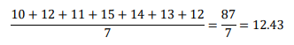
2, Median (Middle Value)
Sorted data: (10,11,12,12,13,14,15)
Middle Value -> 12
3, Mode (most frequent value)
The number 12 appears -> Mode 12

Q2, Mean in Real Life
A teacher records the marks of her students in a short quiz; (12,15, 14, 16, 18, 20, 19).
What is the mean score, and what does it tell us about the class’s performance?
Ans: -
Scores (12, 15, 14, 16, 18, 20, 19)
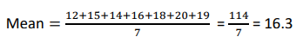
This tells is that, on average, the class scored around 16 Marks, so the students did pretty well.

Q3, Mode in Real Life
A store records the shoe size sold in one day: [7,8,9,8,8,10,7,9].
What is the mode, and why is this information useful for the store manager?
Ans: -
Mode: 8
Use: It tells the manager which shoe size sells the most, so they know which size to keep more of in stock.
Q4, Median in Real Life
A car dealer notes the price of used cars: [$8,000, $9,500, $10,200, $11,000, $50,000].
Why is the median is better measures then the mean in this case? Calculate the Median.
Ans: -
Median: $10,200 (The Median Value)

Q5, Descriptive Introduction
A student times how long it takes to finish a puzzle each day: [25, 30, 27, 35, 40].
What does the range tell us about the variation in the student’s puzzle-solving time?
And: -
The range is 40 – 25 = 15 Minutes.
The Range shows that the student’s puzzle – solving time varies by 15 Minutes from the fastest day to the slowest day. It gives an idea of how spread out the time are.

Q6, Range in Action
A farmer records the weekly weight of harvested apple (kg): [100, 105, 98, 110, 120].
Find the range.
How can this help the farmer in planning his packaging?
Ans: -
The range is 120 – 98 = 22 Kg.
Knowing the range shows how much the apple harvest varies each week. The farmer can use this to plan packaging better, making sure there’s enough space or boxes for weeks with heavier harvests and avoiding waste in lighter weeks.

Q7, Variance for Decision – Making
Two delivery companies track delivery delays (in minutes).
Company A: variance = 6
Company B: Variance = 15 which company is more consistent, and why?
Ans: -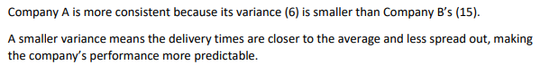
Q8, Standard Deviation in Context
A finance student compares the daily price fluctuations of two cryptocurrencies.
Coin A: standard deviation = $30
Coin B: Standard deviation = $120
Which coin is riskier to invest in, and why?
Ans: -
Coin B is riskier to invest in because it’s standard deviation ($120) is much higher than Coin A’s ($30).
A higher standard deviation means the price fluctuates more, so the investment is less predictable and riskier.
Q9, Combining Measures
Ans: -
Step 1: Find the mean
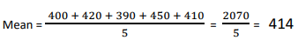
1, Find the difference form the mean and square them,
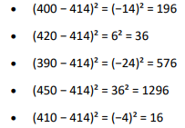
2, Find the average of these squared difference (variance),
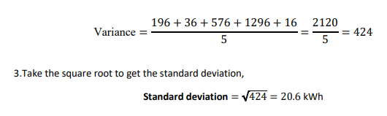
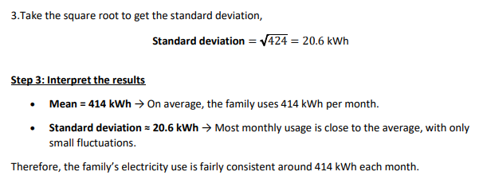
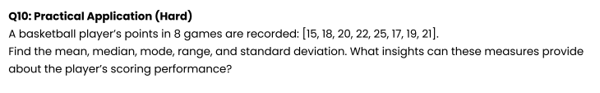
Ans: -
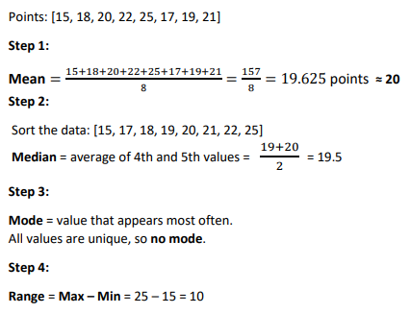
Steps 5: Standard deviation
1, Find difference from mean and square them:
